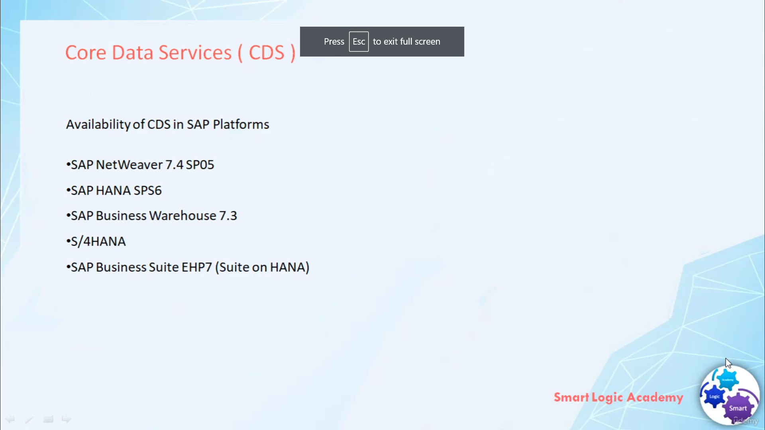

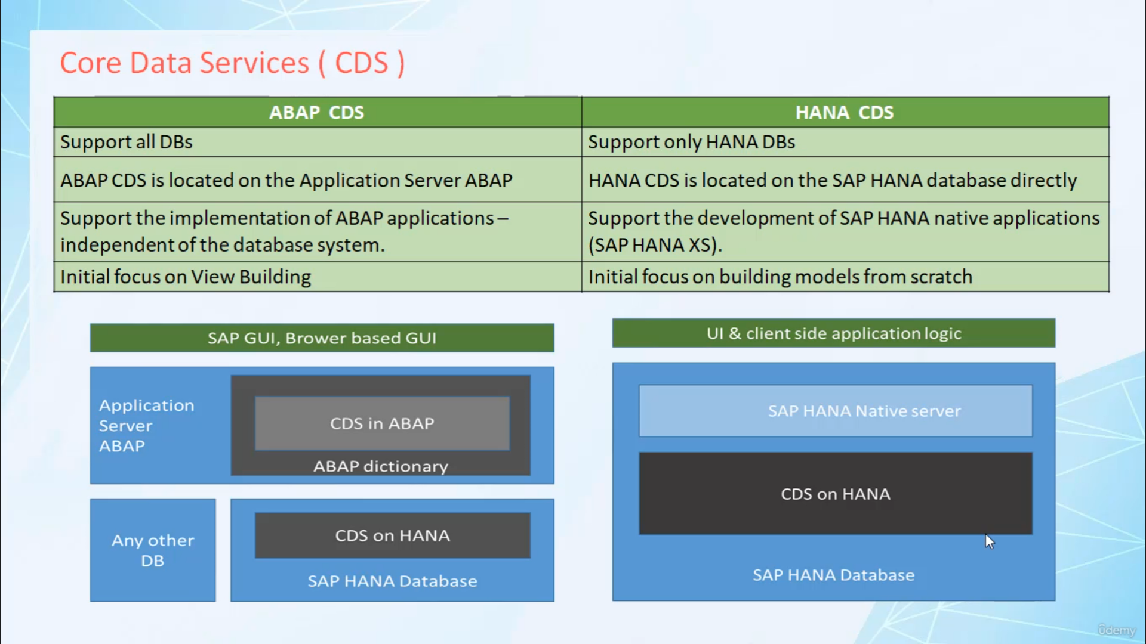

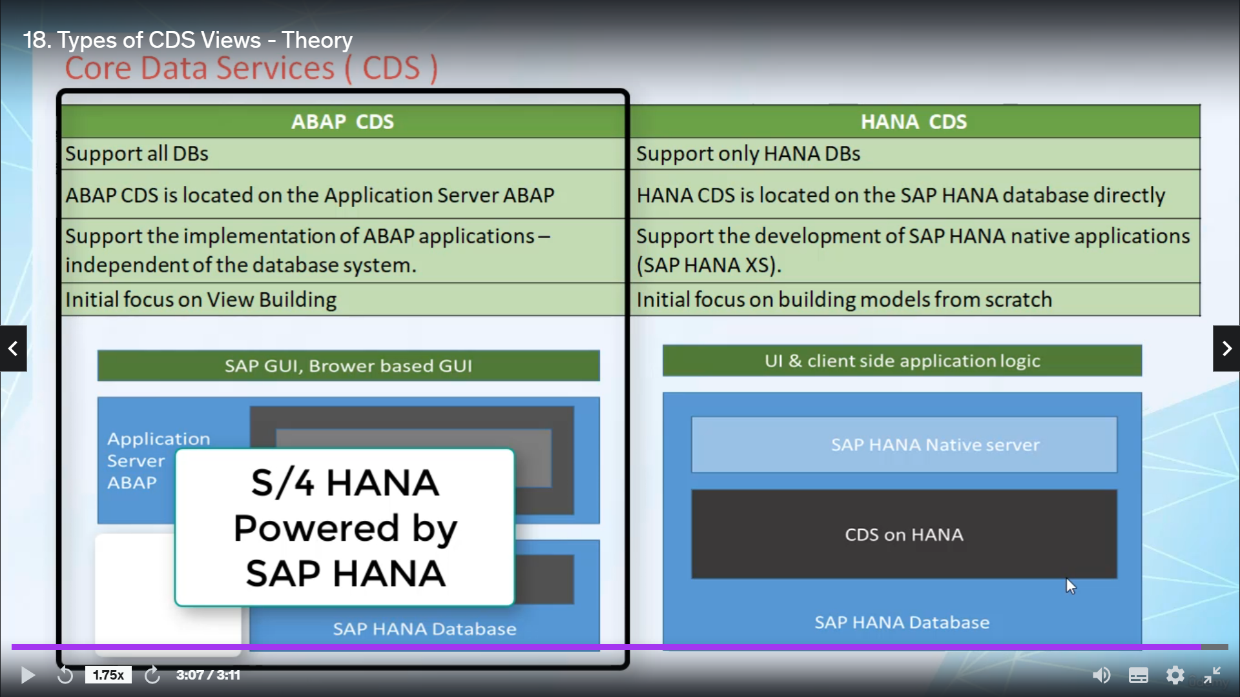

In this video, I will tell you about the different SAP platforms where you can develop Core Data Services

and I will also tell you the exact scenario for which we will develop CDS in this course.

So let's start, Core Data Services is available in various SAP platforms.

I have listed here some of the SAP platforms.

SAP NetWeaver 7.4 SP05

and above.

SAP HANA SPS6

and above versions.

SAP

Business Warehouse 7.3 and above versions, S/4 HANA, SAP business suite

EHP7 and above versions.

So all these are the SAP platforms where you can have CDS Core Data Services.

CDS Core Data Services are of two types, ABAP CDS and HANA CDS

Let's find out what are the differences between ABAP CDS and HANA CDS.

ABAP CDS support all types of database.

For example, ORACLE, HANA etc. whereas HANA CDS supports only HANA database.

ABAP CDS is located on application server whereas HANA CDS is located on the SAP HANA database.

the main purpose of ABAP CDS is to support the implementation of ABAP applications independent

of the database system. whereas the main purpose of HANA CDS is to support the development of

SAP HANA native applications.

the initial focus of ABAP CDS is on VIEW building whereas the initial focus of HANA CDS is

on building DATA Model. Here are the two diagrams, the first diagram shows ABAP CDS use and the second diagram

shows HANA CDS use.

The primary concern of this course is to learn how to optimize ABAP applications directly running on

SAP HANA database i.e applications using SAP HANA as a primary database underneath the ABAP stack. So typical

example of this kind of application is S/4 HANA powered by SAP HANA.

In this course, we will learn how to define and consume ABAP CDS and not about the HANA CDS.

The main focus of this course is to develop ABAP CDS for S/4 HANA application.